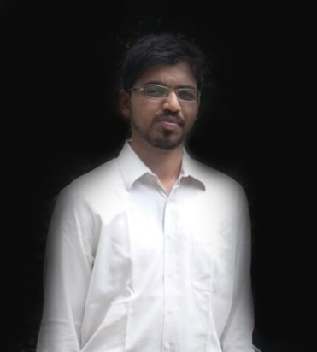

**Hussain Yahya Jariwala**

Mobile: 00919823273521

Email: [hussain.jariwala@hotmail.com](mailto:hussain.jariwala@hotmail.com)

**OBJECTIVE:**

Main objective is to be associated with a prestigious organization where I can showcase my skills and my talents in order to enhance professional techniques and gain experience.

**EDUCATION:**

* **Bachelors:** Pursuing – B.Com

College: Indira Gandhi National Open University (IGNOU)

* **Diploma** in Customer Service – September 2016

College: Alison Institute (Securing 80%)

* **H.S.C :** Year 2005

College: Poona College of Arts, Science & Commerce

* **S.S.C :** Year 2003

School: National Institute of Open Schooling

**WORK EXPERIENCE:**

* **September 2014 – Present**

**Designation:** Sr. Customer Care Officer at WNS (Process : AVIVA)

**Responsibility Handled:** Medium of communication between the customer and the organization. Handling customer queries with regards to the Vehicle Insurance Policies. Target oriented, Documentation and data entry is handled, while 50 claims are completed on daily basis, Customer satisfaction and customer delight is the main focus at WNS.

* **September 2012 – October 2013**

**Designation:** Customer Care Officer at IBM (Process : Advance Auto Parts)

**Responsibility Handled**: Business to Business. Handling telephonic enquiries, Resolving Customer issues and customer quires. Be the medium of correspondence between the client and the company. Getting the best results by utilizing the resources available at the work place while generating appreciable results.

* **August 2011 – January 2012**

**Designation :** Customer Support Officer at EXL Services (Process : Sunshine)

**Responsibility Handled:** Convincing customers to insure their home and valuables. Bringing in the awareness of policy at all India level to the masses across the country. Being a brand ambassador to the product, I have been responsible to the value of the product.

* **January 2009 – June 2011**

**Designation :** Customer Support Officer at Mphasis (Process : Santander Bank)

**Responsibility Handled:** Handling the account holders by giving them assurance of the bank which bought the customer to build confidence in the bank. Dealt with Credit card, Debit Card, Insurance, Saving Accounts, Current Accounts, and Money transfer. Mentoring new staffs and inducting them into the system was taken care.

**PERSONAL DATA:**

**Date of Birth:** 02 April 1985 ( Second April Nineteen Eighty Five)

**Place of Birth:** Pune, India

**Nationality:** Indian

**Address:** 28/2 Safe Society Block No 7 B.T. Kawde Road, Pune 411013

**Passport No.:** J7105207

**Strengths: Excellent** Communication Skills, Team Worker, Team Player Quick Learner, can work under pressure and meet deadlines, efficiently and trustworthy.

**Software Skills:** MS Office, MS Word, MS Excel, MS Outlook.

**Languages Known:** English, Hindi, Gujarati, Marathi

**Interests:** Reading books, net surfing, bike riding, meeting new people , exploring new places, movies.

**REFERENCE:** Mr. Leo D.Costa, Assistant Manager, WNS Global Services, Pune (00919623733826).